CREATE A SIMPLE CLOUD SOFTWARE APPLICATION FOR PROPERTY BUYING & RENTAL PROCESS (IN CHENNAI CITY) USING ANY CLOUD SERVICE PROVIDER TO DEMONSTRATE SAAS.

PROCEDURE:

STEP1: GOTO ZOHO.COM
STEP 2: LOGIN TO THE ZOHO.COM STEP 3: SELECT ONE APPLICATION STEP 4: ENTER APPLICATION NAME STEP 5: CREATED NEW APPLICATION STEP 6: SELECT ONE FORM
STEP 7: THE SOFTWARE HASE BEEN CREATED.

SAMPLE OUTPUT (with Data)

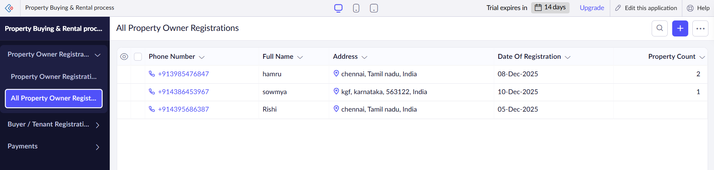

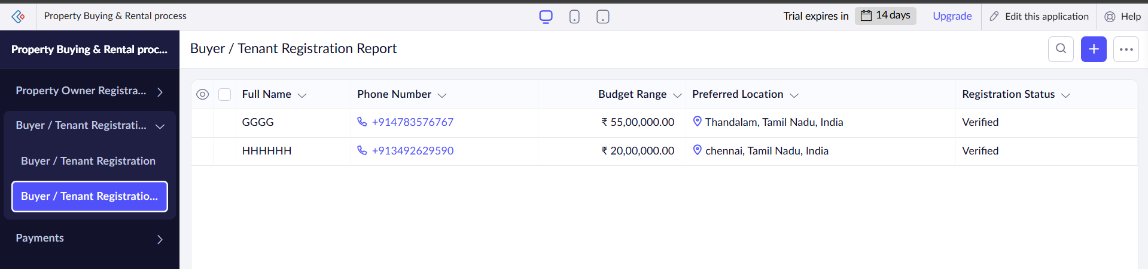

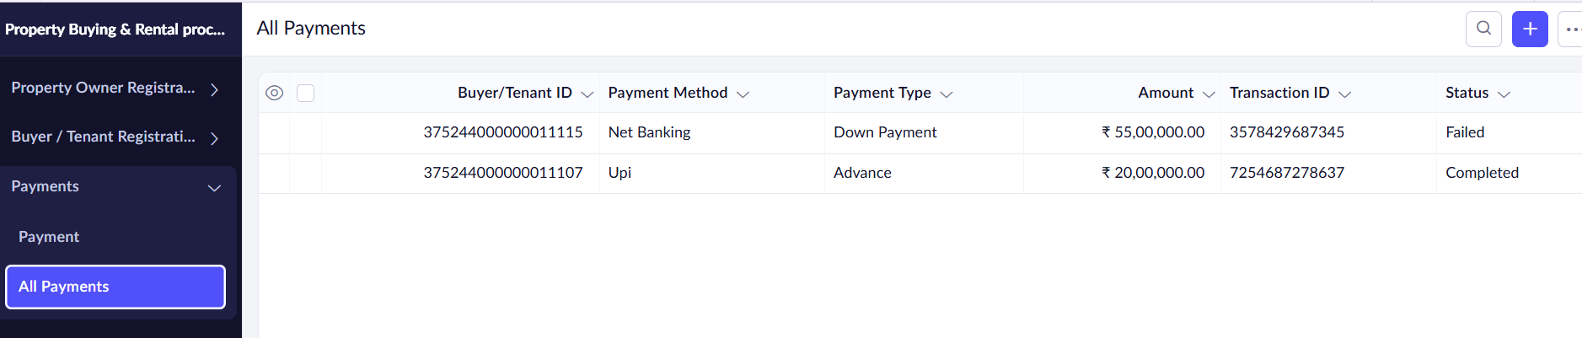

RESULT

Thus the Property Buying & Rental Process System is implemented using Zoho Software.

